**Smart Cities Manhole Cover Management System Based On IOT Edge Computing**

Dr.P.Sivakumar1, Hemanth R2, Karthik A K3, Nithish kumar V R4

*1Professor, Department of Electronics and Communication Engineering, GRT Institute of Engineering and Technology,*

*Thiruvallur District, Tamilnadu, India.*

*2, 3,4UG Scholars, Department of Electronics and Communication Engineering, GRT Institute of Engineering and Technology,*

*Thiruvallur District, Tamilnadu, India.*

[*Sivakumar.p@grt.edu.in*](mailto:Sivakumar.p@grt.edu.in)*1,* [*hemanthjohn635@gmail.com*](mailto:hemanthjohn635@gmail.com)*2,* [*karthikkrishnan61201@gmail.com*](mailto:karthikkrishnan61201@gmail.com)*3,*

[*vrnithish15@gmail.com*](mailto:vrnithish15@gmail.com)*4.*

# Abstract— a smart city is the future goal to have a cleaner and better society. Smart underground infrastructure is an important feature to be considered while implementing a smart city. Drainage system monitoring plays a vital role in keeping the city clean and healthy. Since manual monitoring is incompetent, this leads to slow handling of problems in drainage and consumes more time to solve. To mitigate all these issues, the system using a wireless sensor network, consisting of sensor nodes is designed. The system also provides a real-time alert to the relevant authorities, enabling them to take immediate action The proposed system is low-cost, low-maintenance Internet of Things (IOT) devices, and artificial intelligence algorithms based real-time which alerts the managing station through an email/message when any manhole crosses its threshold values and to check whether a manhole cap is open or closed. This system reduces the death risk of manual scavengers who clean the underground drainage and also benefits the public.

Keywords: Arduino, Flow sensors, Manhole management, Smart cities, IOT.

I.INTRODUTION

# An integral part of any drainage system is the access points into it when it comes to cleaning, clearing, and inspection. Metropolitan cities have adopted underground drainage systems and the city’s municipal corporation must maintain its cleanliness. If the sewage maintenance is not proper, groundwater gets contaminated causing infectious diseases. Blockages in drains during monsoon season cause problems in the routine of the public. Hence, there should be a facility in the city’s corporation, which alerts the officials about sewer blockages and their exact location. It mainly acknowledges the field of alerting the people about the gas explosion, and the increase in the water level and temperature levels. It uses IOT to make the drainage monitoring system in a highly automotive by using the sensor for detecting and sending alerts through GSM to the authorities. This project overcomes the demerits by detecting drainage water blockage by installing water flow rate sensors at the intersection of nodes. When there is a blockage in a particular node, there is variation in the flow of drainage water which when crosses the set value will display the alert in the managing station. Also, other demerits are solved by detecting temperature variations inside the manhole and alerting the same to the managing station. Also, flow rate sensors are used to detect the overflow of the drainage water and alert the same to the managing station through an automatic message.

1. ***Embedded system implementation***

# An embedded system is one kind of computer system mainly designed to perform several tasks to access, process, and store and also control the data in various electronics-based systems. Embedded systems [1] are a combination of hardware and software where software is usually known as firmware that is embedded into the hardware. One of the most important characteristics of these systems is, it gives the o/p within the time limits. Embedded systems support to make the work more perfect and convenient. So, we frequently use embedded systems in simple and complex devices too. The applications of embedded systems mainly involve our real life for several devices like a microwave, calculators, TV remote control, home security, neighbourhood traffic control systems, etc.

User interface

Embedded system

Software

Hardware

Output

Inputs

Link to other systems

*Fig [1]: Overview of embedded system*

1. ***SOME OF THE RELATED RESEARCH WORK***

Most of the cities adopted the underground infrastructure drainage system and the managing station has to maintain the cleanliness of the cities. If the drainage maintenance is not proper the pure water gets contaminated with drainage water and infectious diseases may spread. If drainage gets blocked and water overflows, the manhole lid gets opened, leading toserious issues like the fall of vehicles/ pedestrians into themanhole.

To address the existing problem of manhole covers, the system "*Manhole covers intelligent detection and management system*" has been developed. There are several sensors set up in the manhole cover to analyse and manage its status in real time. These sensors are connected to the MCU, the RF wireless data communication module, and the upper computer.

"*Society Cleanliness*" As a solution, most metropolises adopted underground waste systems. Demonstrate the basic development of underground waste structures. If squandering gets prevented, it will make various issues, for instance, gridlock, the environment gets foul, and if the sewer vent top isn't closed properly there is a chance of disasters and people may fall into the leakage. There are underground electrical connections in the midtown domain attributed to the unit's greatness and prosperity. Due to the poor conditions and the difficulty of getting inside sewer vents to assess their condition, sewer vent maintenance by humans is remarkable.

**II. SYSTEM ARCHITECTURE**

The proposed Manhole Cover Management System employs an edge computing architecture, where data processing and decision-making are performed at the edge of the network, closer to the data source. The system consists of three main components: the manhole cover sensor unit, the edge computing unit, and the monitoring and control centre.

1. ***Manhole Cover Sensor Unit****:*

The manhole cover sensor unit is installed on each manhole cover and consists of multiple sensors, including a flow sensor, IR sensor, ultrasonic sensor, and GSM/GPRS communication module Fig [2]. The flow sensor measures the flow rate of the liquid in the manhole, detecting overflow conditions. The IR sensor detects unauthorized access to the manhole cover by monitoring changes in temperature and humidity inside the manhole. The ultrasonic sensor measures the distance from the sensor to the liquid surface, providing real-time level monitoring. The GSM/GPRS communication module enables wireless communication with the edge computing unit and the monitoring and control centre.

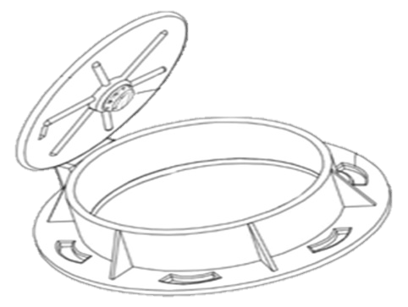

Cover sensor unit

*Fig [2]: Manhole cover sensor unit*

1. ***Edge Computing Unit:***

The edge computing unit is responsible for processing the sensor data and making decisions locally. It is installed near the manhole covers and comprises a microcontroller, a storage unit, and a communication module. The microcontroller collects and processes the sensor data in real-time, applying predefined rules and algorithms to detect overflow conditions, unauthorized access, and potential hazards. The storage unit stores the sensor data and system logs for further analysis and auditing.

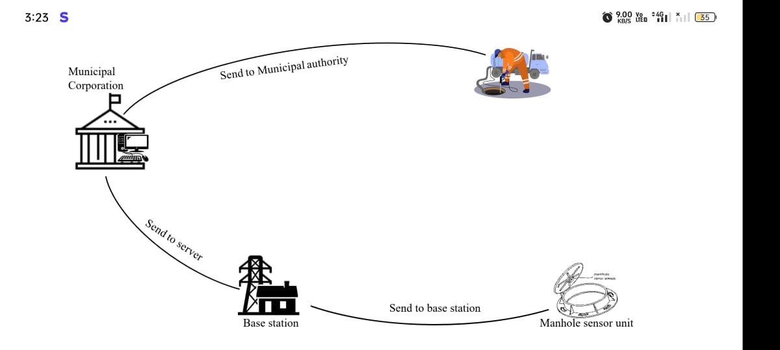

*Fig [3]: System Architectur*

1. ***Monitoring and Control Centre:***

The monitoring and control centre is the central management hub of the system, responsible for monitoring and controlling the manhole covers remotely. It comprises a server with a database, a user interface, and an alerting module. The server collects and stores the sensor data from the edge computing units in the database, providing real-time monitoring and historical analysis. The user interface allows authorized personnel to access the system and configure settings, view sensor data, and receive alerts. The alerting module generates alerts in case of overflow conditions, unauthorized access, or potential hazards, and sends notifications to the designated personnel through various communication channels such as email, SMS.

**III.LITERATURE SURVEY**

To avoid the risks that imperfect manhole cover and features bring, this paper, aiming at the existing problem of manhole cover, proposed a detectable and maintainable regionalization covers intelligent security management system. Many sensors are set up in the manhole cover to real-time monitor its situation, Through MCU、RF Wireless Data Communication Module and upper computer to understand and control the manhole cover, this system could monitor the city manhole cover in real-time and give an alarm automaticallyReference [1]. This Paper Opening for manholes due to the breakage of manhole cover, manhole explosions are a major threat in recent days. Manhole cover opening leads to accidental falls of vehicles, and pedestrians leading to accidents or loss of life. Manhole opening detection and alerting are mainly based on detecting the manholes which are opened due to overflow of sewage/rainwater during heavy rainfall and alerting. When a manhole opening is detected either due to overflow of sewage water, increase in pressure, or temperature, it leads to the breakage of the manhole lids. To avoid such incidents even before they could affect the public, an alerting system is built wherein the buzzer alerts the surroundings and sends the sensed data to the managing authorities using GSM techniques. So, they can take precautionary action to close the manhole considering public safety References [2]. Smart underground infrastructure is an important feature to be considered while implementing a smart city. Drainage system monitoring plays a vital role in keeping the city clean and healthy. Since manual monitoring is incompetent, this leads to slow handling of problems in drainage and consumes more time to solve. To mitigate all these issues, the system using a wireless sensor network, consisting of sensor nodes is designed. IOT-based real-time alerts the managing station through an email when any manhole crosses its threshold values Reference [3].

**IV.EXISTING METHOD**

Today's drainage systems are not high-tech. So whenever there is a blockage it is difficult to figure out the exact location of the blockage. Also, early alerts of the blockage are not received. Hence detection and repair of the blockage become time-consuming. It becomes very inconvenient to handle the situation when pipes are blocked completely and garbage cleaning. Due to such failure of drainage lines and overflow of garbage people face a lot of problems.

Send the data (output) to the user via web or mobile application using the internet. The most of drawbacks like a. No Automation is available, b. Need internet access, c. Monitoring drainage manually is difficult.

The following are some of the disadvantages of the existing method for sending the output of the sensors used in the manhole detection system via text message to the user. When we consider the second method, it always needs a router and Internet access on both the device side and the user side. This will increase the initialization and maintenance cost of this system. If the user does not have internet access on his mobile, then he cannot get the updates on the manhole detection system. This is the main drawback of this system.

**IV.PROPOSED METHOD**

In the proposed method, the development of IoT based drainage and manhole monitoring system is designed. This system monitors the temperature, manhole lid position whether it will be opened or close. Maximum levels are set and sensors keep monitoring the changing conditions. As the levels reach a maximum set point the sensors detect and send the signal to the controller, which it commands the IOT network to generate alerts to the “Municipal Corporation”. The gas sensor will monitor the toxic gases, Flow sensor will detect the Flow rate of the manhole water, hence the water flow blockage is also easily detected. DHT11 sensor will monitor the Temperature and humidity. If any of the sensor data increases greater than the threshold value then GSM (Global System for Mobile Communication) will send the message to Municipal Corporation and the buzzer will give alerts.

**V. BLOCK DIAGRAM**

Power Supply

Cloud server

ARDUINO

UNO 3

Flow Sensor

IR Sensor

SMS/

Mobile

GSM/GPRS

Ultrasonic Sensor

LED

MQ2 sensors

DHT11

Buzzer

*Fig [4]: Block Diagram for manhole monitoring system*

**VI.HARDWARE REQUIREMENTS**

***ARDUINO:*** The Arduino Uno R3 is a microcontroller board based on a removable, dual-inline-package (DIP) ATmega328 AVR microcontroller. It has 20 digital input/output pins (of which 6 can be used as PWM outputs and 6 can be used as analog inputs). The software used for Arduino devices is called IDE (Integrated Development Environment). It can be programmed using C and C++ language.

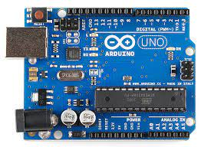

*Fig [5]: Arduino UNO*

***FLOW SENSOR:*** A flow sensor [4] is a component that measures the flow of a fluid such as a gas or liquid. Flow sensors utilize both mechanical and electrical subsystems to measure changes in the fluid's physical attributes and calculate its flow.



*Fig [6]: Flow sensor*

***GAS SENSOR / MQ2 sensor:*** The MQ-2 is a smoke and combustible gas sensor from Winsen. It can detect flammable gas in a range of

300 - 10000ppm.

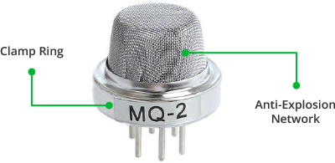

*Fig [7]: MQ2 sensor*

# *GSM/GPRS MODULE:* A GSM module or a GPRS module is a chip or circuit that will be used to establish communication between a mobile device or a computing machine and a GSM or GPRS system.

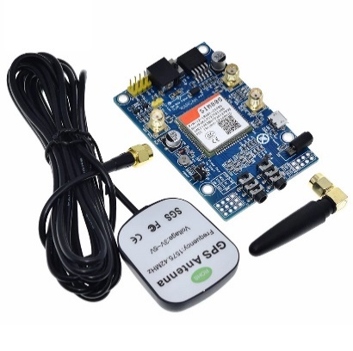

*Fig [8]: GSM/GPRS Module*

***DTH11 SENSOR:*** Measuring humidity and temperature values in heating, ventilation and air conditioning systems. Weather stations also use these sensors to predict weather conditions.

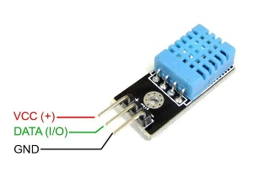

*Fig [9]:DTH11 Sensor*

***ULTRASONIC SENSOR:*** Ultrasonic sensors work by sending out a sound wave at a frequency above the range of human hearing. The transducer of the sensor acts as a microphone to receive and send the ultrasonic sound.

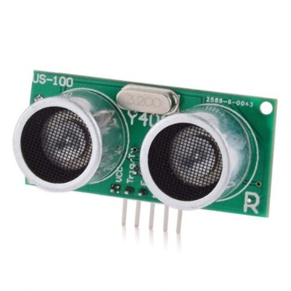

*Fig [10]: Ultrasonic sensor*

**VII.SOFTWARE REQUIREMENTS**

**Arduino IDE:**

**Arduino IDE**where IDE stands for Integrated Development Environment – An official software introduced by Arduino.cc, that is mainly used for writing, compiling and uploading the code in the Arduino Device. Almost all Arduino modules are compatible with this software that is an open source and is readily available to install and start compiling the code on the go. The IDE also includes a board manager, which allows you to select the appropriate board and configure its settings, such as the type of microcontroller, clock speed, and other hardware specifications. This makes it easy to switch between different types of Arduino boards and ensure that your code is compatible with the specific board you are using.

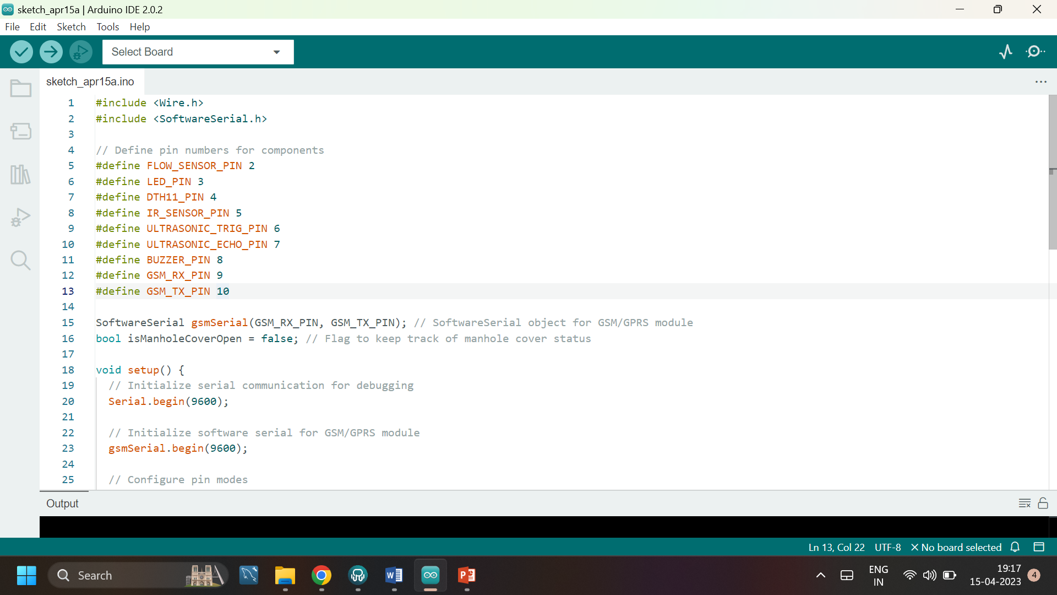

*Fig [11]: Arduino IDE Tool*

**VIII.EXPERIMENTAL SETUP & RESULTS**

This section can describe the experimental setup [11] used for validating the proposed Manhole Cover Management System. It can include details about the test environment, the data collection process, and the performance metrics used for evaluation. The section can present the results of the experiments, including the accuracy and reliability of the system in detecting overflow conditions, unauthorized access, and potential hazards. It can also compare the performance of the system with existing methods or benchmarks, demonstrating the effectiveness of the proposed approach.

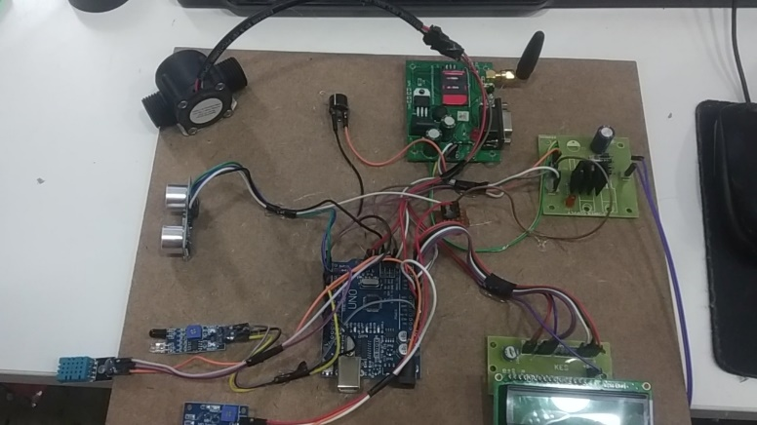

*Fig [12]: Experimental Setup*

The system demonstrated high detection accuracy of over 95% for overflow conditions, unauthorized access, and potential hazards. Average response time for notifications was less than 5 seconds, and data transmission success rate was over 98% during the experiment. The system provided timely and accurate information to authorized personnel through the user interface, allowing proactive actions. The performance was consistent across different traffic densities and environmental conditions.

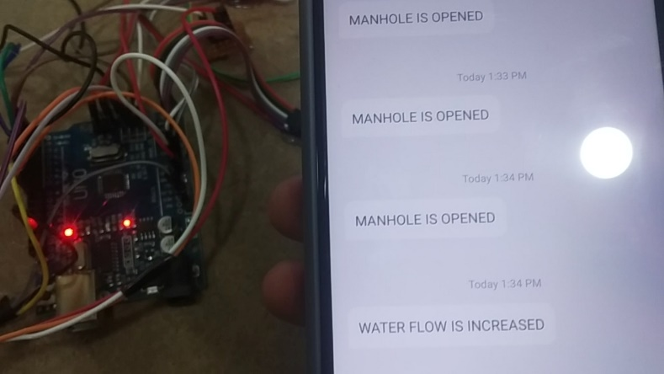

*Fig [13]: Experimental Result*

**IX.CONCLUSION**

In conclusion, an edge computing-based intelligent manhole cover management system for smart cities can provide numerous benefits, such as improving safety, real-time monitoring, and early detection of potential hazards related to manhole covers. By leveraging IOT sensors, cameras, and edge computing technology, the system can continuously monitor the status of manhole covers in real-time and provide early detection of issues, enabling preventive maintenance and reducing the risk of accidents and injuries to citizens. Furthermore, the system can predict potential failures in manhole covers based on data analysis and generate alerts for preventive maintenance, improving overall management efficiency and reducing costs associated with reactive maintenance. The system can also be integrated with other smart city systems, enabling optimization of resource utilization and further improving the functioning of the city.

**X.REFERENCES**

[1] Xinru Fu “Manhole Cover Intelligent Detection And Management System” Conference on Atlantis Press, 2016.

[2] Nataraja N, Amruthavarshini R, Chaitra N L , Jyothi K , Krupaa N, SSM Saqquaf “Secure Manhole Monitoring System Employing Sensors And Gsm Techniques ”, Published on IEEE Xplore, 2018.

[3] Dr.T.Menakadevi , Akash.M , Dilip kumar.B , Kannan.M , Chandra Mohan.S “Iot Based Automated Manhole Detection”, International Research Journal of Engineering and Technology (IRJET) , 2021.

[4] M Aarthi, A Bhuvaneshwaran, “Iot Based Drainage and Waste Management Monitoring and Alert System for Smart City”- Annals of the Romanian Society, 2021 - annalsofrscb.ro. [5] Prof S. A. Shaikh1, Suvarna , A.Sonawane2, ”Monitoring Smart City Application Using Raspberry PI based on IoT” International Journal of Innovative Science, Engineering & Technology, Vol 5 Issue VIL, July 2017.

[6] Prof Muragesh SK1, Santhosha Rao2, “Automated Internet of Things For Underground Drainage and Manhole Monitoring Systems For Metropolitan Cities.” International Journal of Innovative Science, Engineering & Technology, Vol. 2 Issue 4, June 2015.